Vue js



# Introduction

## What is vue js

* A JavaScript framework for building user interfaces.
* A JavaScript framework to create a reactive web application easier

## Before can start the Vue js

* Install the Node js
* Install the NPM
* Commands
  + npm create vue@latest
  + vue create name-project
  + Enter * 8
  + cd name-project
  + npm install
  + **npm run serve**

## install the npm

* npm install -g npm@latest

## check version npm

* npm --version

## check the version vue

* npm v vue

## How to run server?

* Run normal : npm run serve

## Change port

* Run with ports: npm run serve -- --port 700

## why vue js?

* the most popular
* easy to leant
* single page

## 2 different

* Vue CLI is a standard tool for Vue.js development and is used to create, configure, and manage Vue.js projects.
  + Install the vue cli: **npm install -g @vue/cli**
  + Create project: **vue create project-name**

## Components

* a component is a reusable Vue instance with custom HTML elements. These components can be reused multiple times or used within other components, essentially making them child components.

### The three things that we need in the component:

* + <template>where the HTML content is.
  + <script> for our Vue code
  + <style> where we write the CSS styling.

## Set up the bootstrap in Vue js

* Npm install boostrapt

## Install the bootstrap in vue js

* Install for css style: **npm install bootstrap**
* User for use **: npm install @popperjs/core**
  + The code in main.js :
* import 'bootstrap/dist/css/bootstrap.min.css';
* import 'bootstrap'; // Ensure this is imported after CSS
* import { createApp } from 'vue';
* import App from './App.vue';
* createApp(App).mount('#app');

# Data binding

## Bind data

* data binding refers to the process of synchronizing the data (JavaScript variables, arrays, etc.) with the Document Object Model (DOM) without manual intervention.

## Methods

* Methods are functions associated with a Vue instance, created using the methods property.
* Use with event
* Calculator

## Event

* Envent is a mechanism for communication between components.

## Vue Directives

### V-bind

* [v-bind](https://chat.openai.com/share/a0a3b8fd-b56e-494b-a384-abd97ed3c271) is a directive used to bind HTML attributes to Vue.js data.

### [V-if and, v-else, and v-else-if](https://chat.openai.com/share/c05dec8d-d55d-49ad-8db7-ac04d8f4f96d)

* v-if: It is used to conditionally render a block of HTML based on the evaluation of an expression.
  + 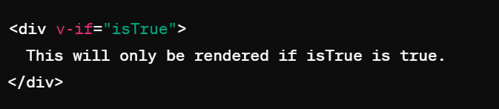
* V-else is condition else{ } in JavaScript
  + 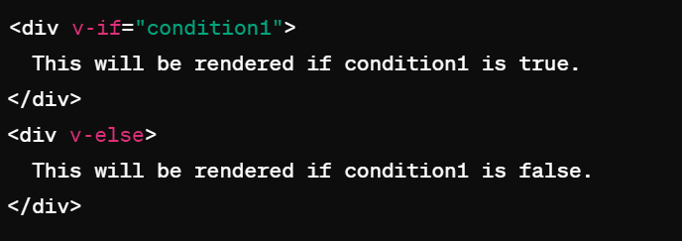
* V-else-if is condition else if { } in JavaScript
  + 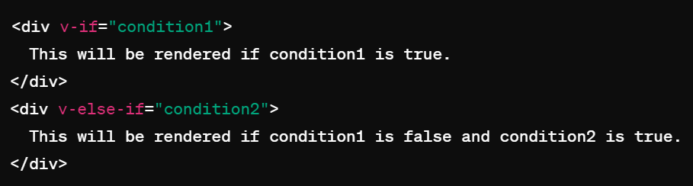

### V-show

* It is used to conditionally render an element based on a Boolean value. If the value is true, the element is displayed; if the value is false, the element is hidden from view.
  + 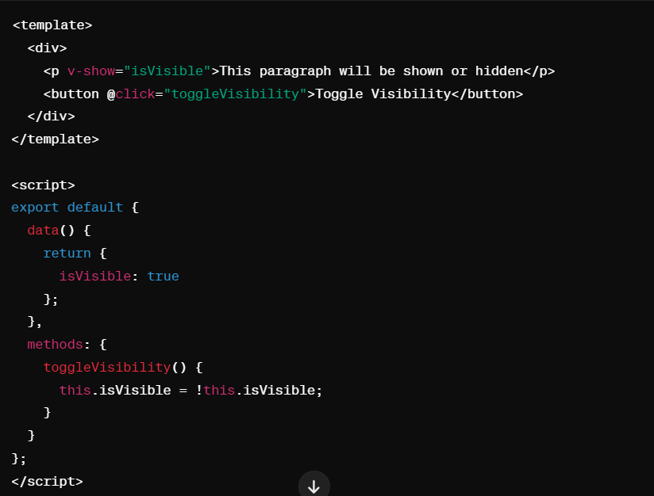

### V-model

* v-model is a directive used for creating two-way data binding on form input elements.
  + 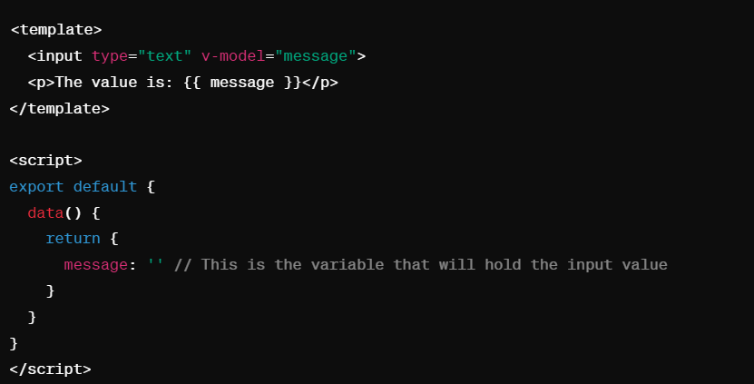

### V-for

* v-for is a directive used for rendering a list of items based on an array or an object.
  + 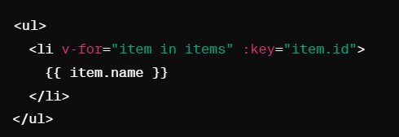
  + 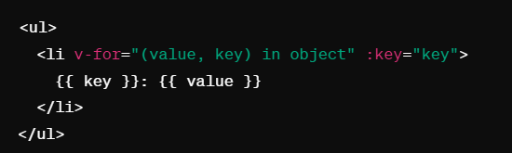

### V-on

* v-on is Connects an event to an action.
  + 
  + 

### V-once

### Vc

### Sdsd

### Dssds

### Dssdsd

### Sd

### Sd

### Sdsd

### c

## Gflkfglk

## Gfll

## H

# Computed and watch

## What is computed in vue?

* are like data properties, except they depend on other properties.
* It similar like the method, but not the parameter is computed
* Intended to compute existing data
* Should use with properties
* It usually use with style

## What are watchers?

* A watcher is an object that watches for changes to a specific property or expression and performs a function when the watched property or expression changes.

## The different of method, computed, and watch

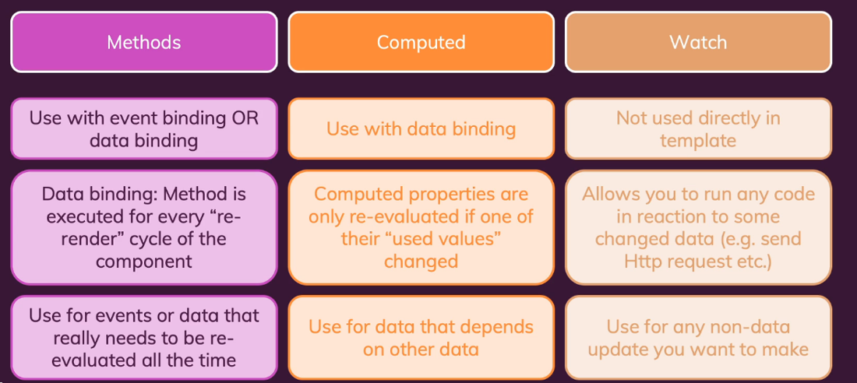

## Vue lifecycle hook

* Provide some method (called lifecycle hooks) to manipulate your app at specific phases

### Mounted

* Use to fetch data

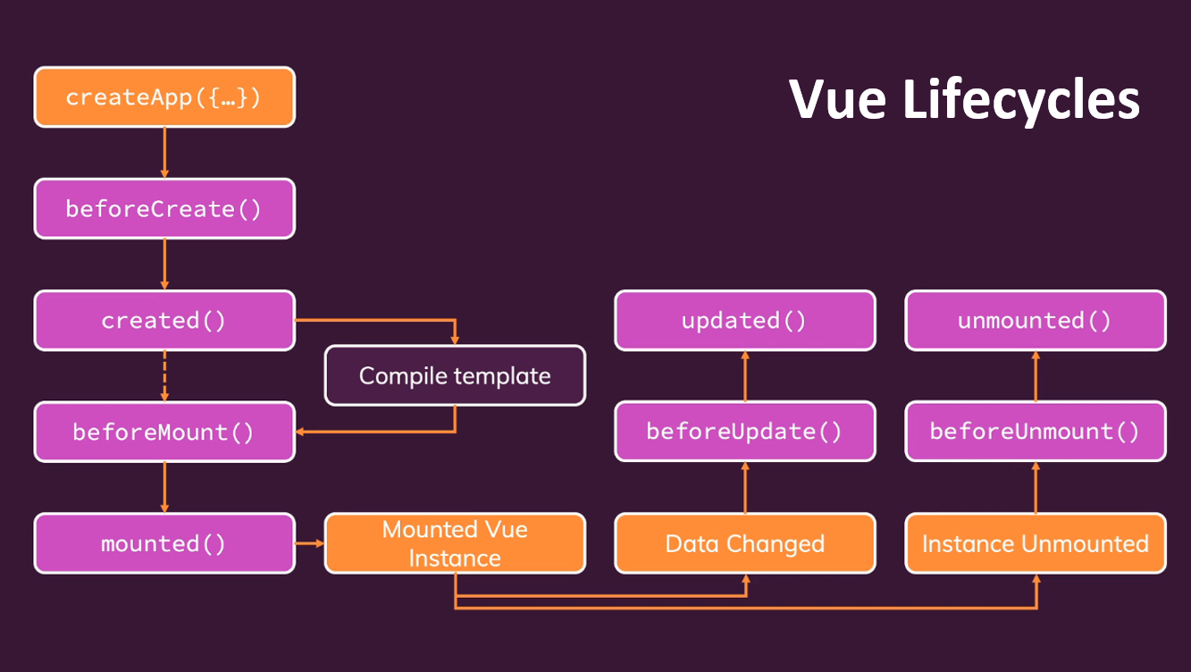

# Component

## What is component?

* Df

# SPA (Single Page Application)

## What is SPA?

* which is a web app that loads a single web document and updates its content using JavaScript APIs. This allows users to use websites without loading entire pages from the server.

## The advantages of SPA

* Loading speed
* Straightforward development
* Easy to debug
* Can be distribute

# Routing

## What is route?

* Vue Router is the official client-side routing solution for Vue

## How to install route in Vue.js

* npm install vue-router

## How to use the route?

## Hdf

## Hdf

## Hdf

## Dhfj

## Dfh]j

## d

# Slot Dynamic components

## What is slot?

* Slot allows to customize the body of the widget
* Slots are a powerful feature in Vue that allow for more flexible and reusable components.
* We use slots in Vue to send content from the parent into the <template> of a child component.
  + 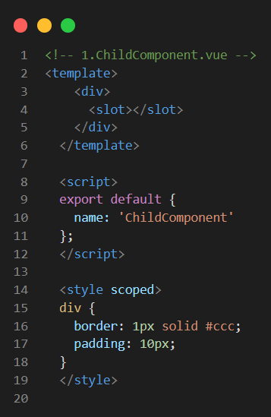
  + 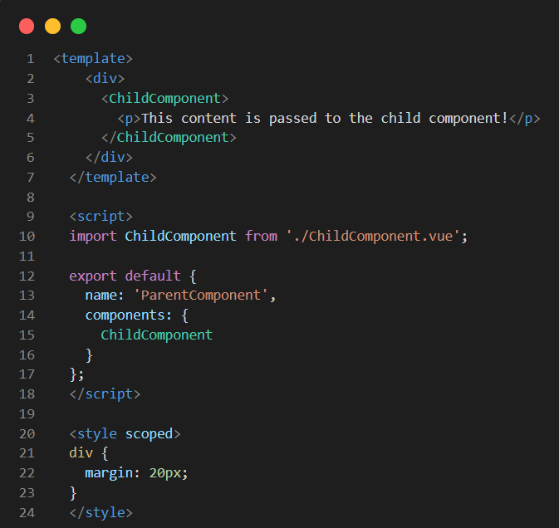
  + 

## Scope and Global style

## Slots: structure components into multiple components

## widget vs component

* Components tend to be larger in scope and encompass multiple UI elements.
* While widgets are smaller and more specific in their purpose. Components are usually self-contained and carry their own logic, whereas widgets often rely on external resources or frameworks for their functionality.
* Widget content many components

## Props vs slots

* Props
* slots

## Good structure folder

* We have to group of files or folders
  + /Components
    - /Customers
      * customerView.vue
      * CustomerCard.vue
      * CustomerFilter.vue

## Ijddjdf

## Dfh

## Dfh

## Dfgh

## F

## hf